# Plan De Pruebas

## Clientes

### Crear Cliente

**CURL:**

curl --location 'http://localhost:8080/api/clientes \

--header 'Content-Type: application/json' \

--data '{

"customerId": "CUST0011",

"name": "Jose Lema",

"gender": "Masculino",

"age": 30,

"identification": "1234567801",

"address": "Otavalo sn y principal",

"phone": "098254785",

"password": "1234",

"state": true

}'

**RESPONSE:**

{

    "customerId": "CUST0011",

    "name": "Jose Lema",

    "gender": "Masculino",

    "age": 30,

    "identification": "1234567801",

    "address": "Otavalo sn y principal",

    "phone": "098254785",

    "password": "1234",

    "state": **true**

}

**POSTMAN:**

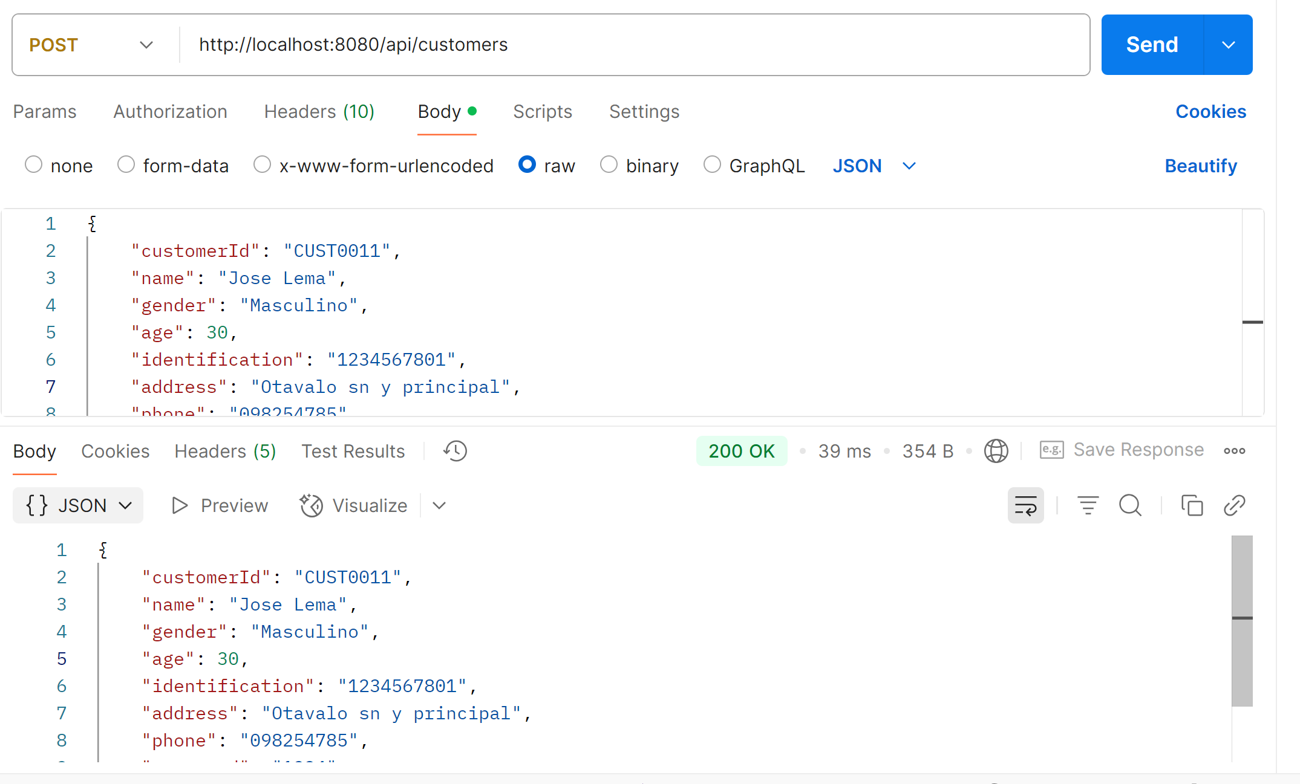

### Actualizar Cliente

**CURL:**

curl --location --request PUT 'http://localhost:8080/api/clientes/CUST0011' \

--header 'Content-Type: application/json' \

--data '{

"address": "Pillaro San Miguelito",

"phone": "0980298828",

"state": false

}'

**RESPONSE:**

{

    "customerId": "CUST0011",

    "name": "Jose Lema",

    "gender": "Masculino",

    "age": 30,

    "identification": "1234567801",

    "address": "Pillaro San Miguelito",

    "phone": "0980298828",

    "password": "1234",

    "state": **false**

}

**POSTMAN:**

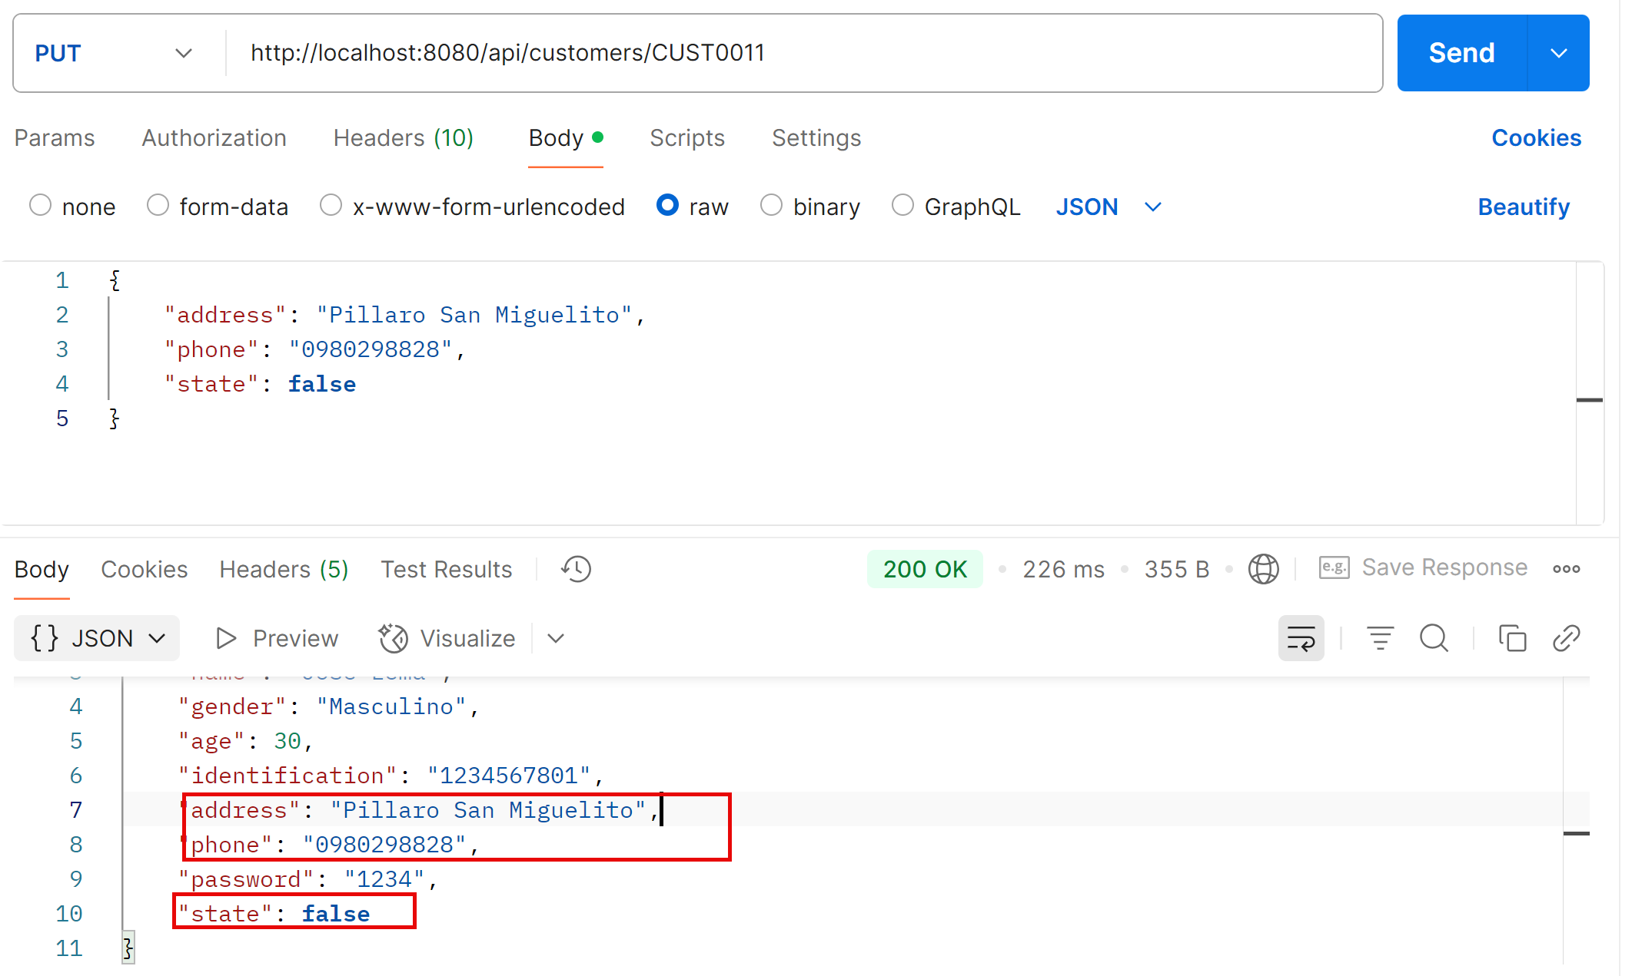

### Consultar Cliente por ClienteId

**CURL:**

curl --location --request GET 'http://localhost:8080/api/clientes/CUST0011' \

--header 'Content-Type: application/json' \

--data '{

"name": "Jose Lema",

"gender": "Masculino",

"age": 30,

"identification": "1234567890",

"address": "Otavalo sn y principal",

"phone": "098254785",

"password": "1234",

"state": true

}'

**RESPONSE:**

{

    "customerId": "CUST0011",

    "name": "Jose Lema",

    "gender": "Masculino",

    "age": 30,

    "identification": "1234567801",

    "address": "Pillaro San Miguelito",

    "phone": "0980298828",

    "password": "1234",

    "state": **false**

}

**POSTMAN:**

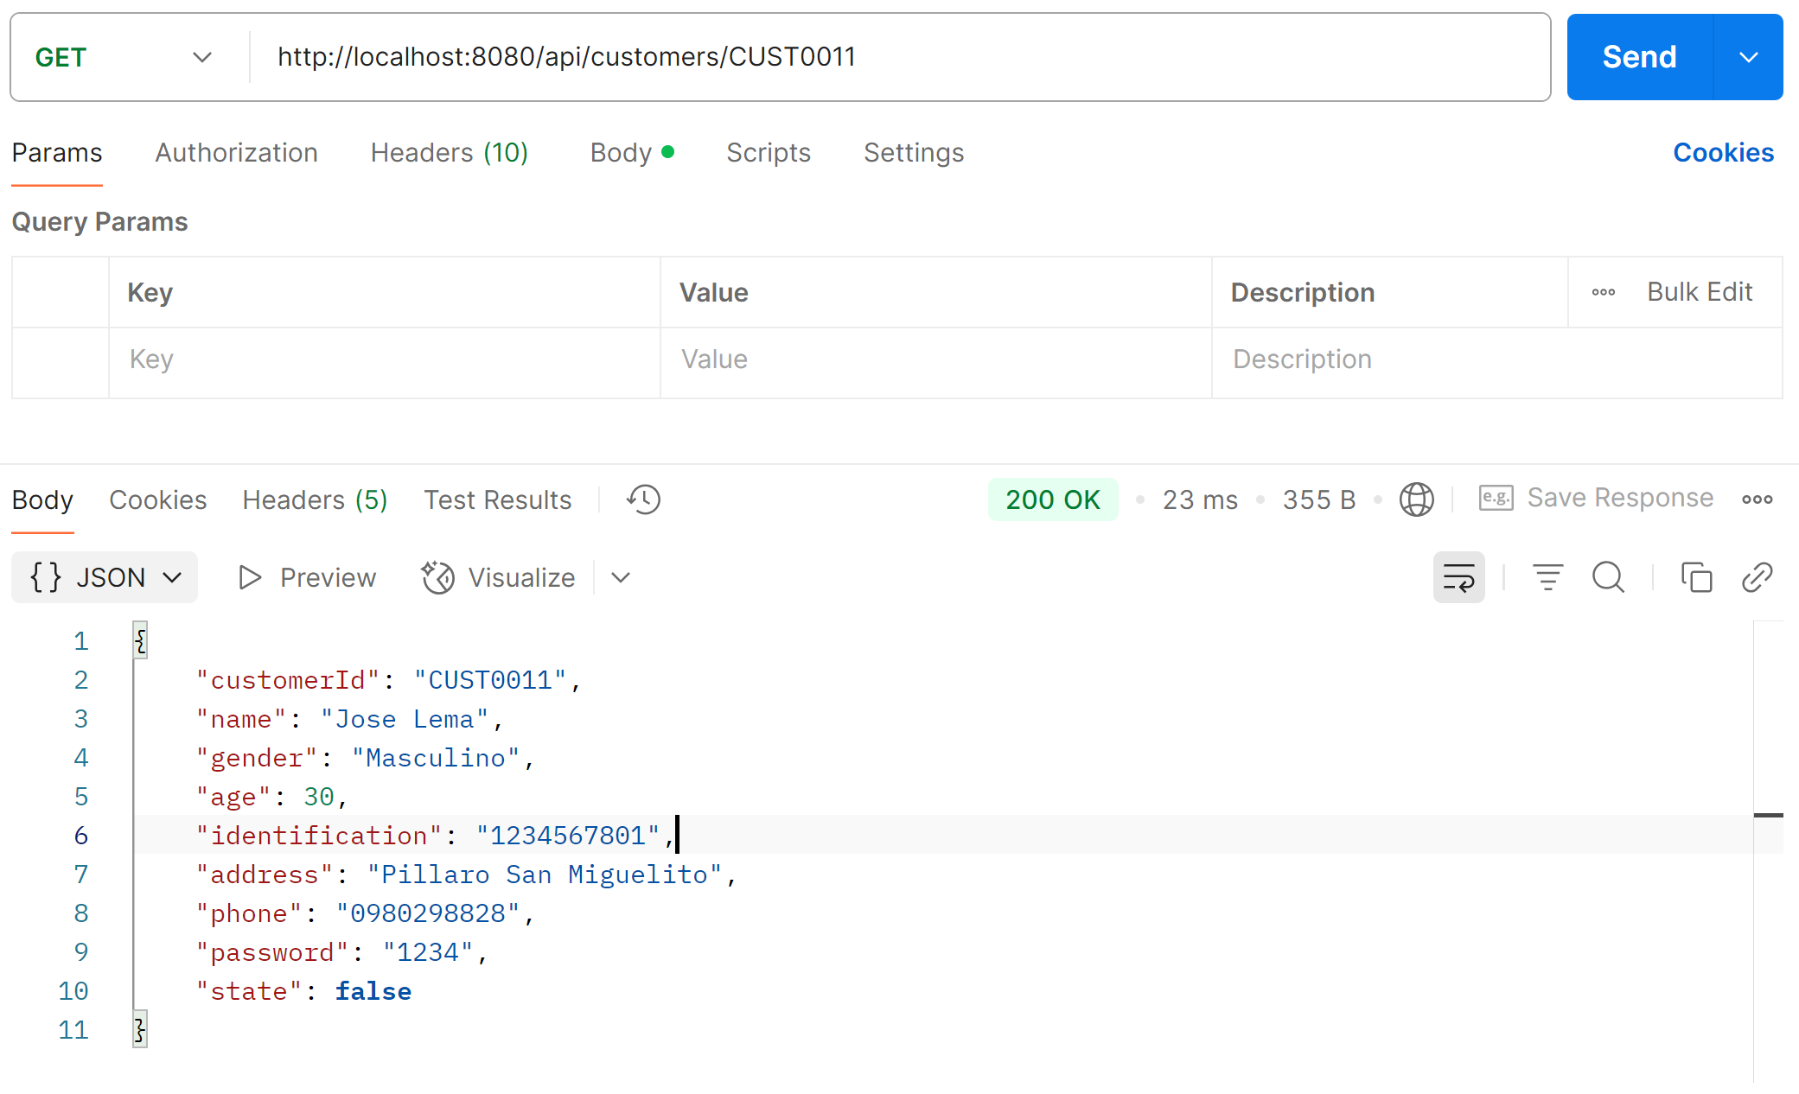

### Eliminar Cliente

**CURL:**

curl --location --request DELETE 'http://localhost:8080/api/clientes/CUST0011' \

--header 'Content-Type: application/json'

**POSTMAN:**

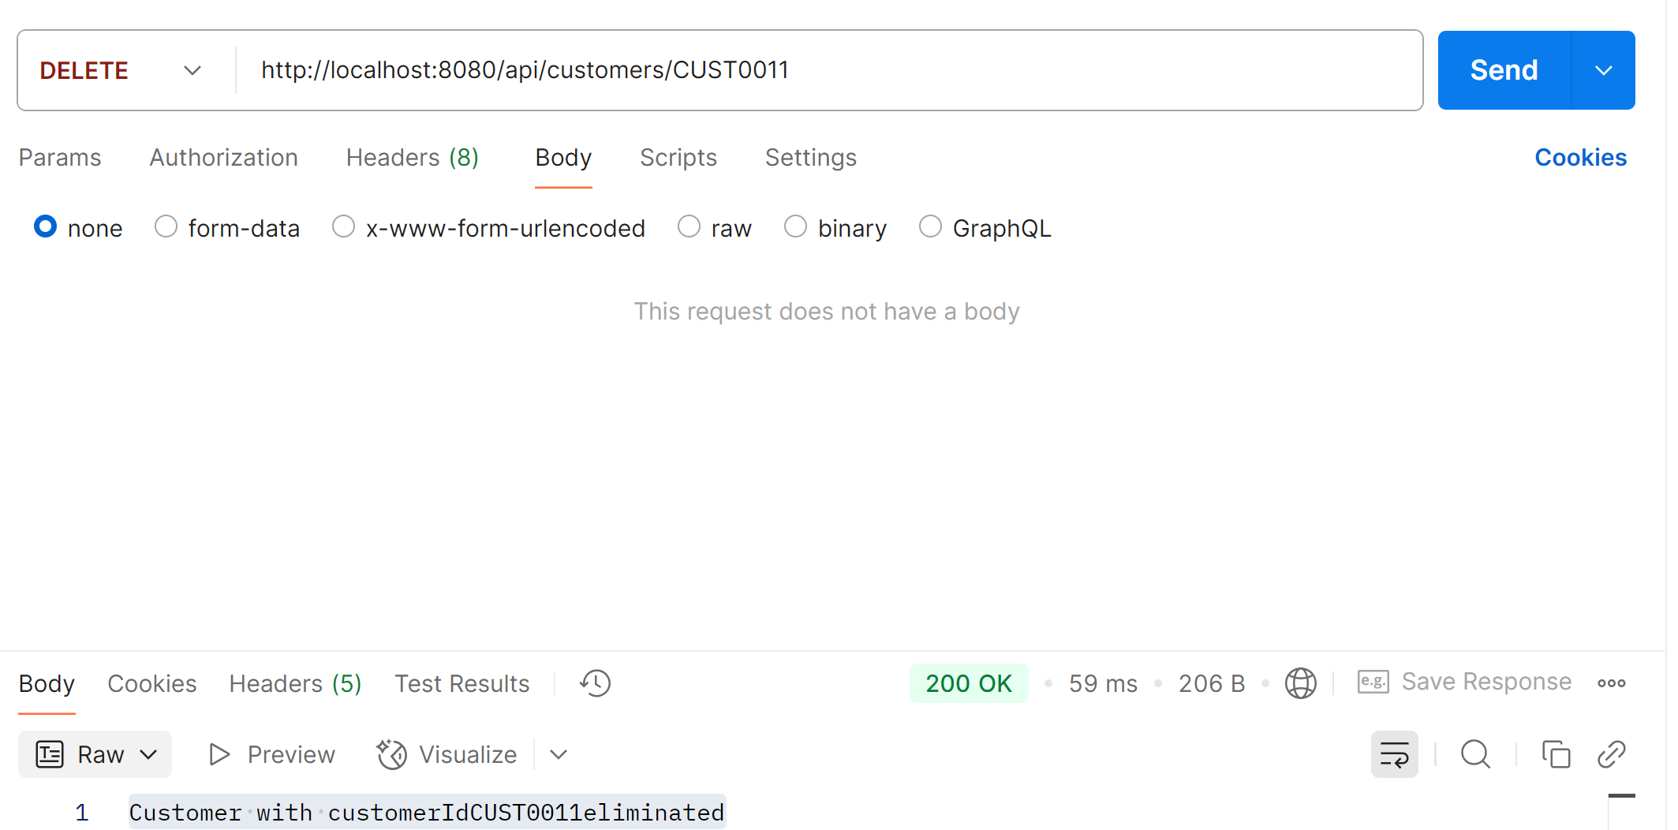

## Cuentas

### Crear Cuenta

**CURL:**

curl --location 'http://localhost:8085/api/cuentas \

--header 'Content-Type: application/json' \

--data '{

"accountNumber": "478758",

"accountType": "Ahorro",

"initialBalance": 2000,

"state": true,

"customerId": "CUST0012"

}'

**RESPONSE:**

{

    "id": 1,

    "accountNumber": "478758",

    "accountType": "Ahorro",

    "initialBalance": 2000,

    "state": **true**,

    "customerId": "CUST0012"

}

**POSTMAN:**

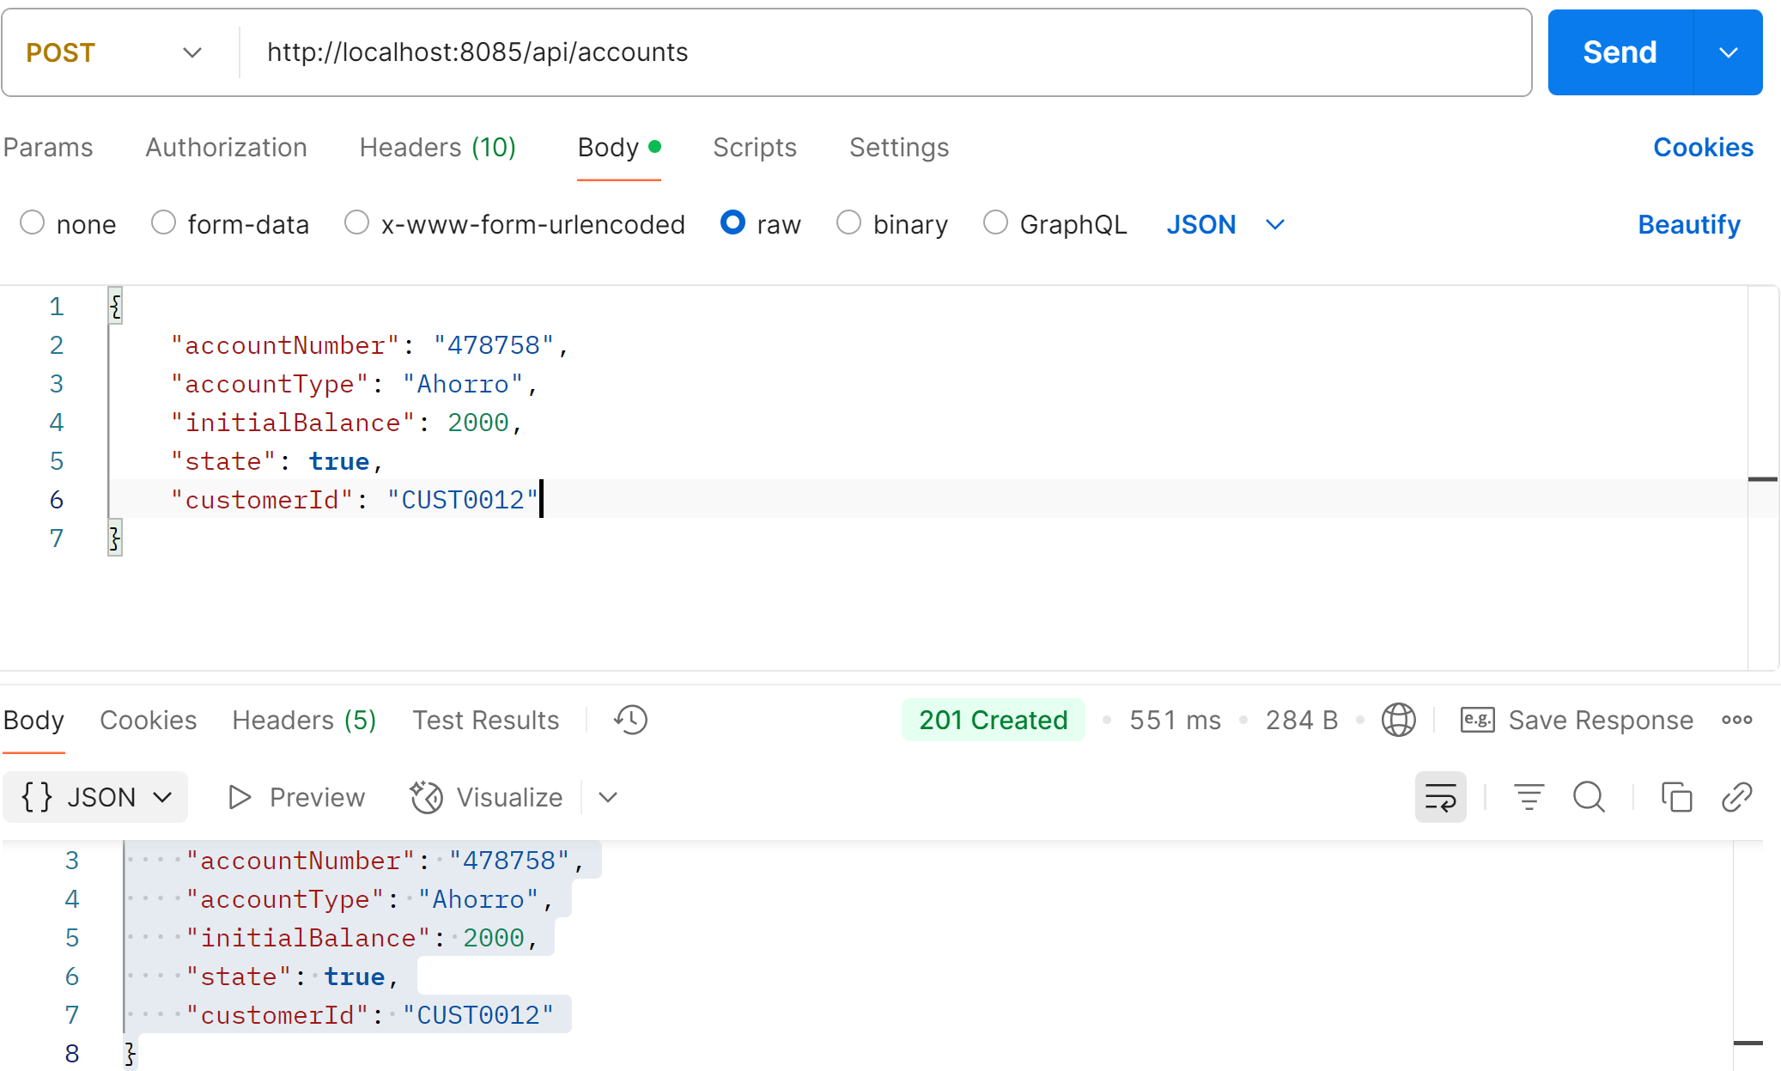

### Actualizar Cuenta

**CURL:**

curl --location --request PUT 'http://localhost:8085/api/cuentas/478758' \

--header 'Content-Type: application/json' \

--data '{

"state": false

}'

**RESPONSE:**

{

    "id": 1,

    "accountNumber": "478758",

    "accountType": "Ahorro",

    "initialBalance": 2000.00,

    "state": **false**,

    "customerId": "CUST0012"

}

**POSTMAN:**

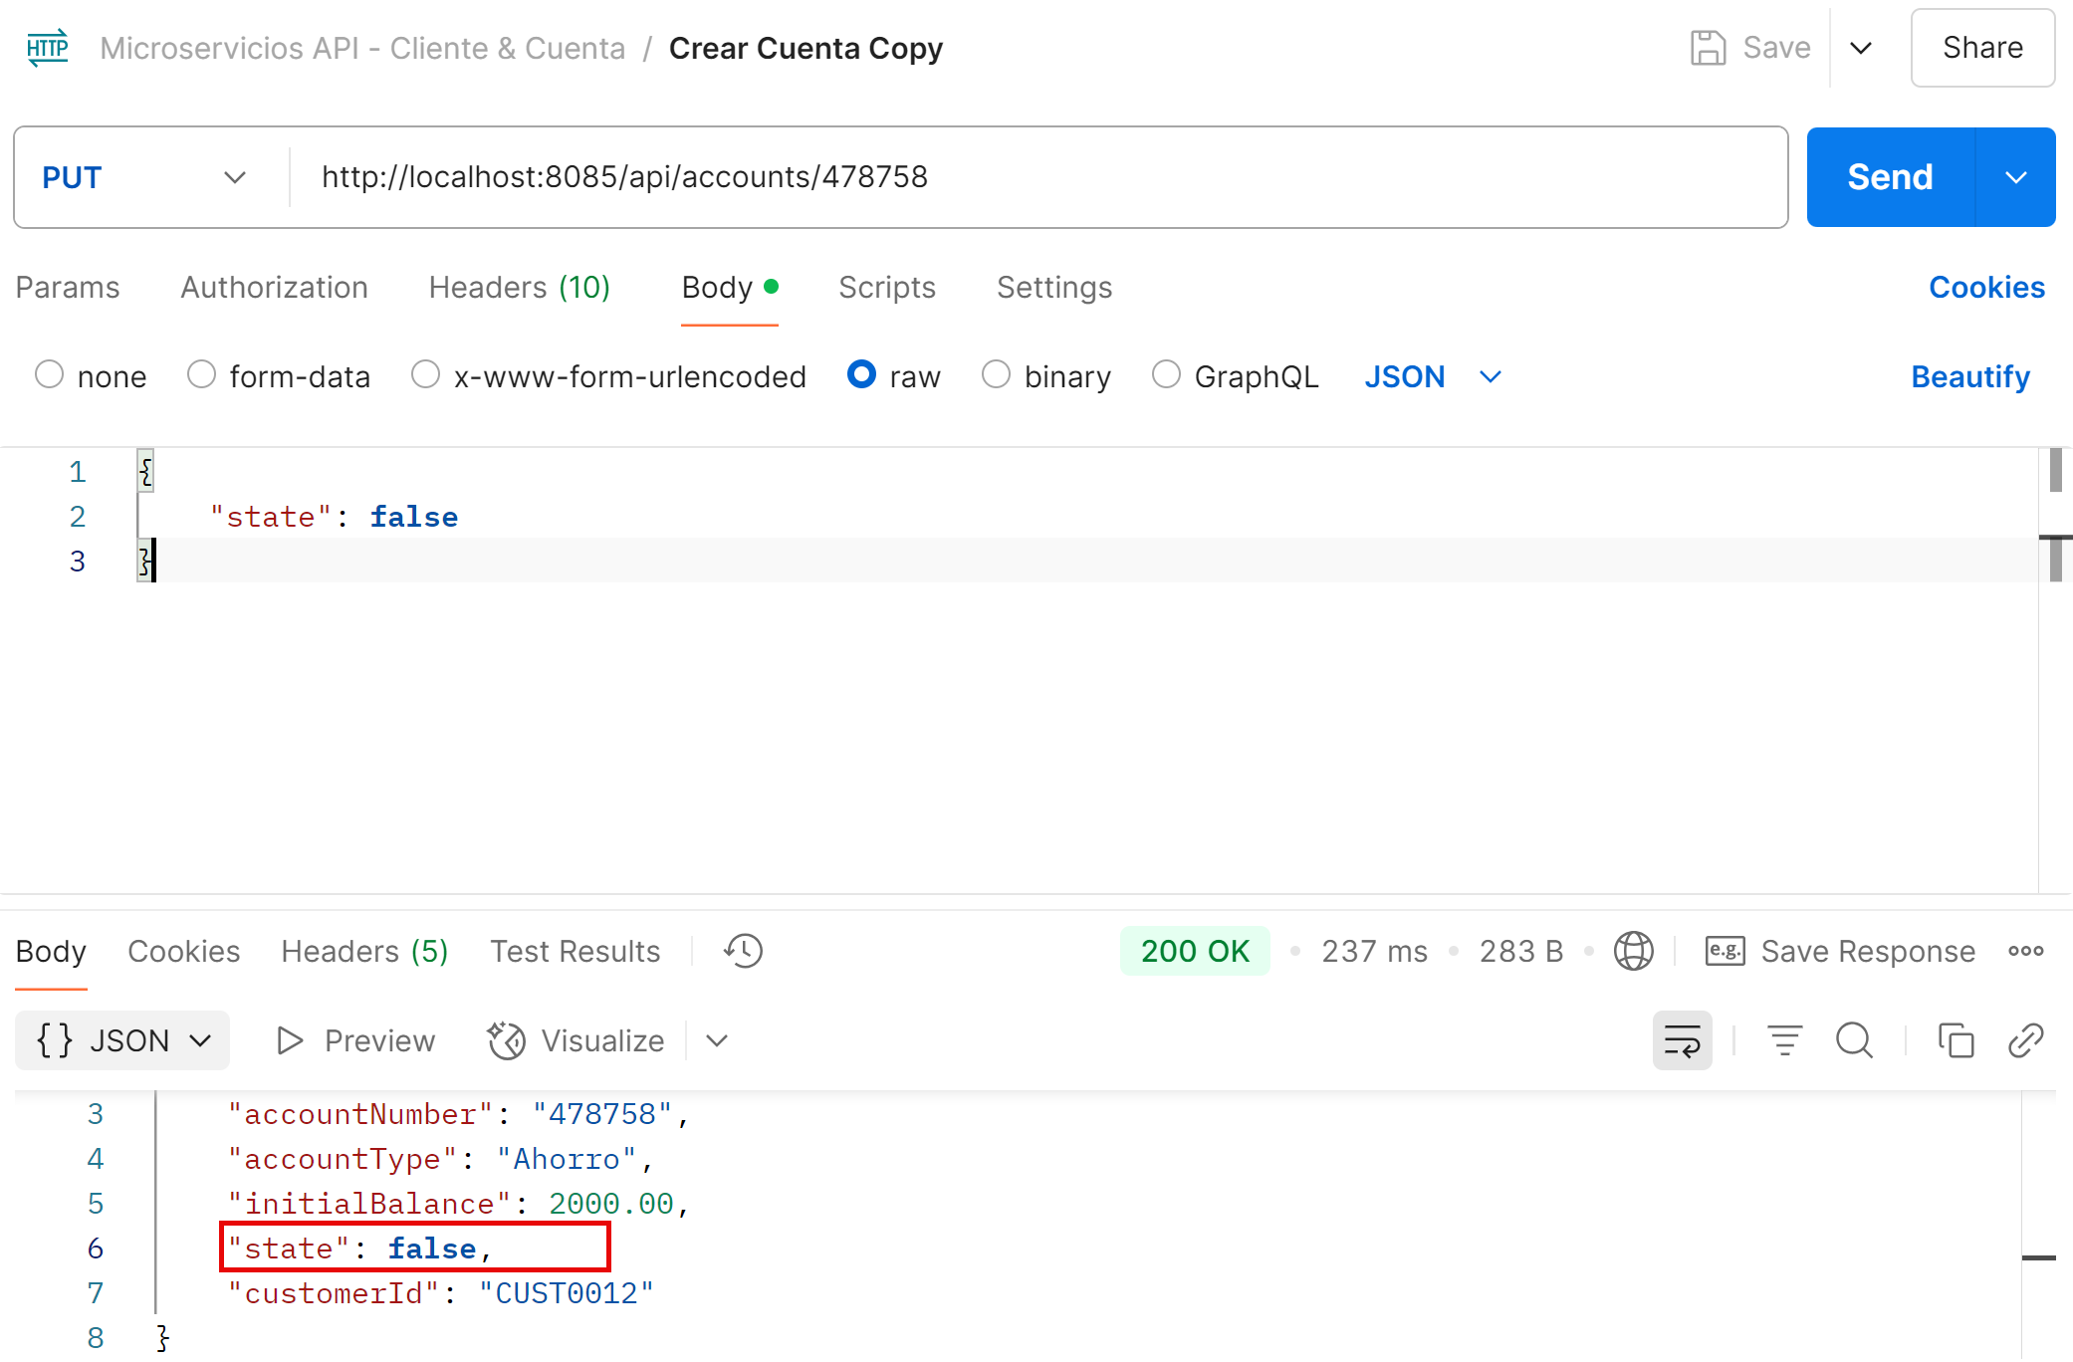

### Consultar por Número de cuenta

**CURL:**

curl --location --request GET 'http://localhost:8085/api/cuentas/478758' \

--header 'Content-Type: application/json' \

--data '{

"accountNumber": "478758",

"accountType": "Ahorro",

"initialBalance": 2000,

"state": true,

"customerId": 1

}'

**RESPONSE:**

{

    "id": 1,

    "accountNumber": "478758",

    "accountType": "Ahorro",

    "initialBalance": 2000.00,

    "state": **true**,

    "customerId": "CUST0012"

}

**POSTMAN:**

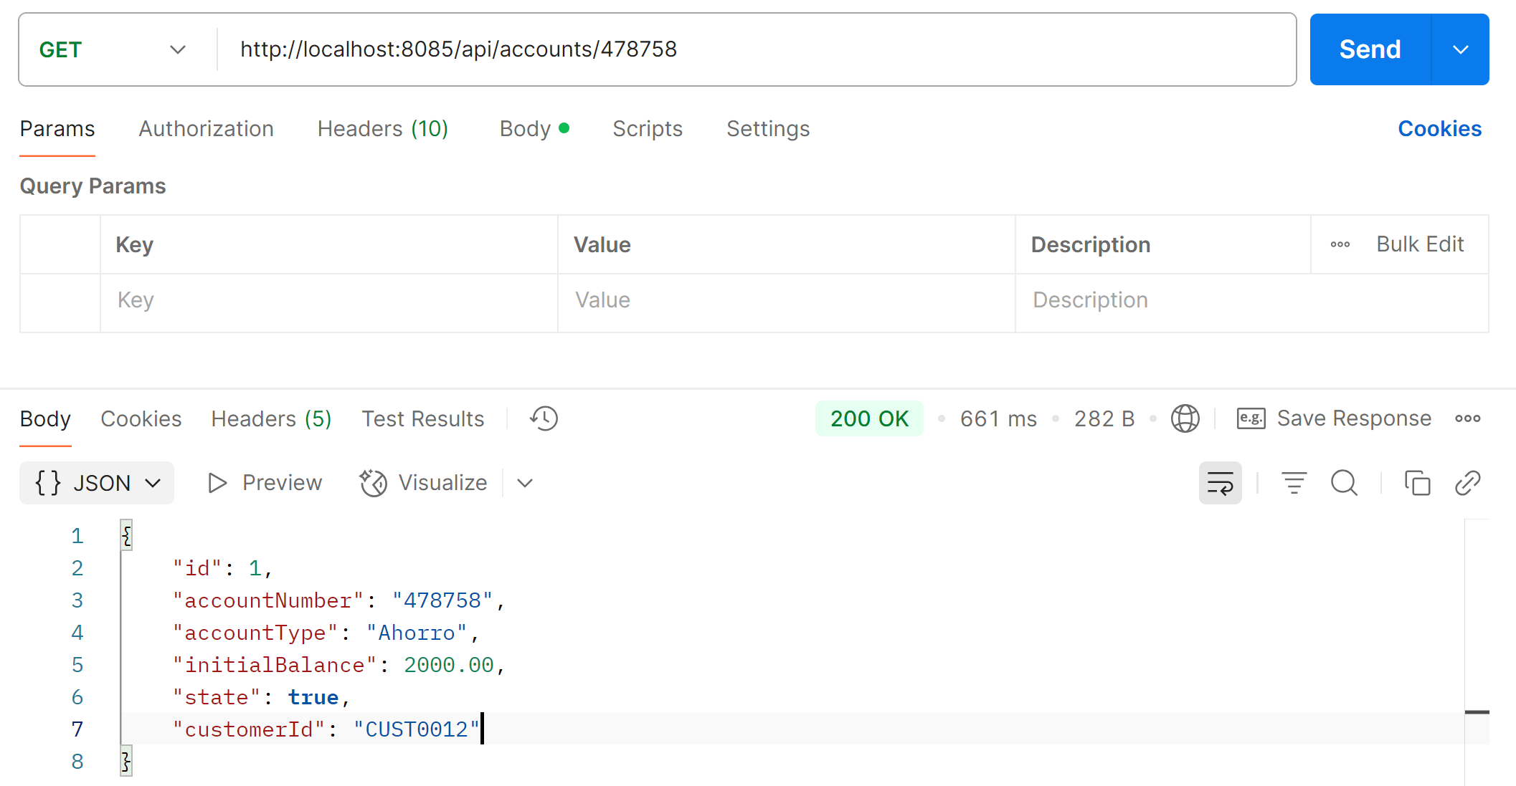

### Eliminar Cuenta

**CURL:**

curl --location --request DELETE 'http://localhost:8085/api/cuentas/478758' \

--header 'Content-Type: application/json'

**POSTMAN:**

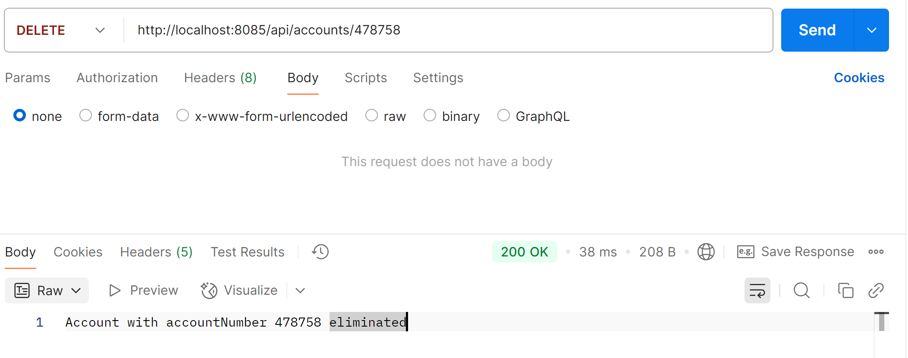

## Movimientos

### Crear movimiento

**CURL:**

curl --location 'http://localhost:8085/api/movimientos' \

--header 'Content-Type: application/json' \

--data '{

"accountNumber": "478758",

"movementType": "RETIRO",

"amount": 300

}'

**RESPONSE:**

{

    "id": 1,

    "date": "2025-04-27T19:18:52.126972192",

    "movementType": "RETIRO",

    "amount": 300,

    "balance": 1700.00,

    "accountNumber": **null**

}

**POSTMAN:**

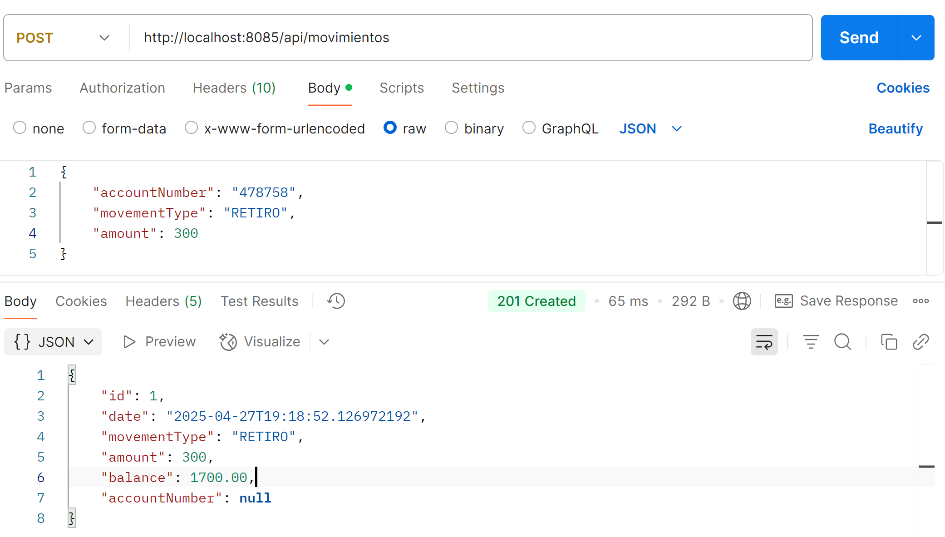

### Reporte

**CURL:**

curl --location 'http://localhost:8085/api/movimientos/reportes?customer=CUST002&desde=2025-04-27T00%3A00%3A00&hasta=2025-04-27T23%3A59%3A59'

**RESPONSE:**

[

    {

        "date": "2025-04-27T19:18:52.126972",

        "customerName": "Jose Lema",

        "accountNumber": "478758",

        "accountType": "Ahorro",

        "initialBalance": 1700.00,

        "state": **true**,

        "movement": 300.00,

        "availableBalance": 1700.00

    }

]

**POSTMAN:**

